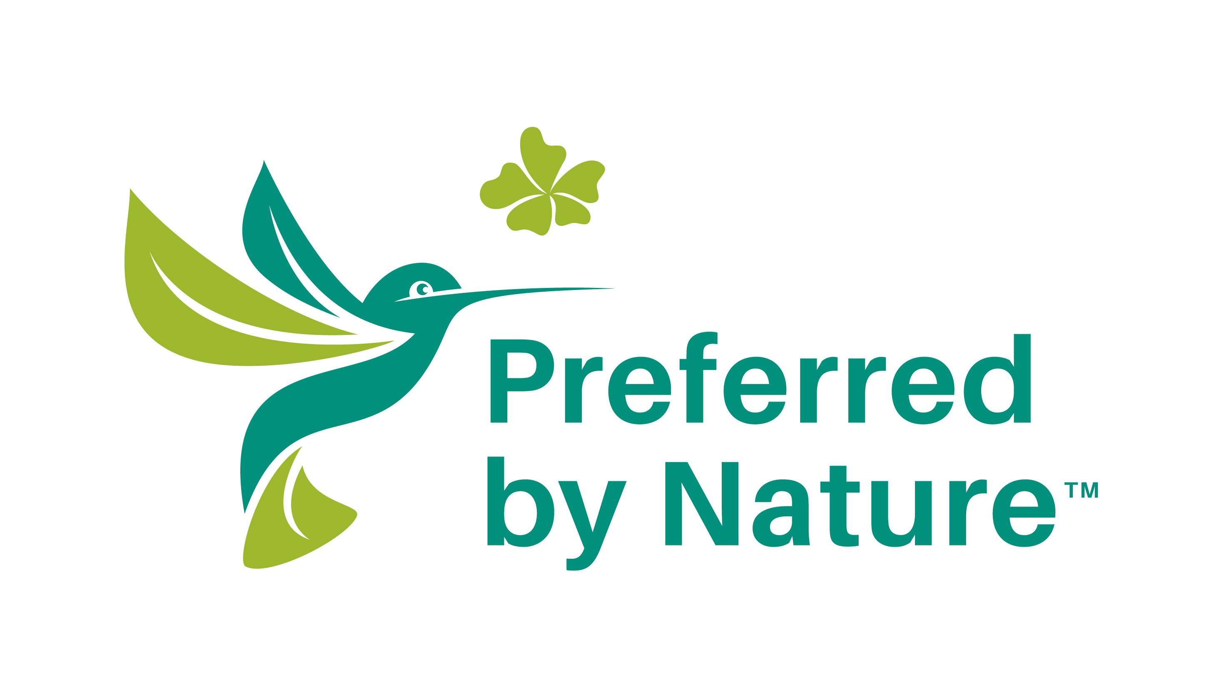

SAMPLE
Outsourcing Agreement
for Non-FSC-certified Contractors

Sample Outsourcing Agreement for Non-FSC-certified Contactors

February 2022

Introduction
IMPORTANT
This document is an extract (Annex 1) of the "Guide to outsourcing of Forest Stewardship Council™ (FSC™) production activities", which is provided by Preferred by Nature as a help for you if you outsource part or all of your FSC-certified production, and which has been designed to provide information you need in order to ensure compliance with the applicable FSC standards and policies.
This sample outsourcing agreement has been designed to help you to comply with the FSC Chain of Custody (CoC) Standard (FSC-STD-40-004 V3-1) by providing an example of how an Outsourcing Agreement for Non-FSC-certified Contractors may be structured.
This is a support tool that you may use voluntarily when developing your own company-specific procedures. It cannot be applied directly. You always need to develop and tailor your own procedures.
Using this document is not mandatory for achieving certification, and does not imply any guarantee or assurance regarding the conformance level of your actual company procedures.
Although we have made an effort to cover all Standard requirements, we do not provide any guarantee as to the completeness of this sample agreement.
NOTE: This sample outsourcing agreement is provided as inspiration for certificate holders worldwide. Therefore, the FSC trademark symbol TM is used throughout this document. In many countries, the registered trademark symbol ® is applicable. You may need to replace the TM used in this sample agreement as part of developing your own company-specific procedures.

SAMPLE

Outsourcing Agreement for Non-FSC-certified Contractors

Certificate Holder’s FSC™ CoC Certificate Code:
Primary Contact for the Certificate:
Contractor’s Company Name:
Contractor Contact Person:
Location of Contractor:
Description of Outsourcing Arrangement:

General Terms for Outsourcing:

- The Contractor shall conform to all applicable certification requirements and the FSC Certificate Holder’s procedures related to the outsourced activity.
- The Contractor shall track and control all materials that are outsourced for use in FSC-certified products to ensure they are not at risk of mixing or being contaminated with any other materials during the outsourcing arrangement.
- The Contractor shall use only the material provided by the FSC Certificate Holder for products covered by this outsourcing arrangement.
- The Contractor shall maintain records of inputs, outputs, and delivery documentation associated with all material processed during the outsourcing arrangement.
- The FSC Certificate Holder shall issue the final invoice for the FSC-certified products following the outsourcing arrangement.
- The Contractor shall not use the FSC or Preferred by Nature trademarks for promotional use or on any products not included in this outsourcing arrangement.
- The Contractor shall not further outsource processing of the material to any other entity.
- The Contractor shall allow Preferred by Nature to conduct audits of its operation, including on-site evaluation, as part of its auditing of the FSC Certificate Holder.
- The Contractor shall agree to conform with the FSC Core Labour Requirements as described in the FSC Certificate Holder’s procedures as follows (main points):
7.2. The organisation shall not use child labour.
7.3. The organisation shall eliminate all forms of forced and compulsory labour.
7.4. The organisation shall respect freedom of association and the effective right to collective bargaining.
7.5. The organisation shall respect freedom of association and the effective right to collective bargaining.

Specific Terms for this Outsourcing Arrangement:

- {IF APPLICABLE} The Contractor shall only apply the FSC labels provided by the FSC Certificate Holder to the FSC-certified products covered by the scope of this outsourcing arrangement and agreement.
- {LIST ADDITIONAL TERMS SPECIFIC TO THIS OUTSOURCING AGREEMENT}

Certificate Holder | Contractor
Signature________________________ | Signature____________________________
Date ____________________________ | Date ________________________________

www.preferredbynature.org

About us
Preferred by Nature (formerly known as NEPCon) is an international non-profit organisation working to support better land management and business practices that benefit people, nature and the climate. We do this through a unique combination of sustainability certification services, projects supporting awareness raising, and capacity building.
For more than 25 years, we have worked to develop practical solutions to drive positive impacts in production landscapes and supply chains in 100+ countries. We focus on land use, primarily through forest, agriculture and climate impact commodities, and related sectors such as tourism and conservation. Learn more at www.preferredbynature.org

Contact
NEPCon OÜ
Filosoofi 31 l Tartu 50108 l Estonia
info@nepcon.org
Phone: +372 7 380 723 l CVR: 10835645

FSC™ A000535 | FSC accredited certification body

